**Name: Muhammad Nur Firdaus Bin Muhamed Haireen**

**Matric No: 1815259**

**Subject: Computation and Complexity (CSC 4101)**

**Challenge 1**

1. Chosen Project Title: Covid 19 Risk Assessment
2. Relation with the state transition: It uses the Deterministic finite automaton in which the system evaluates every condition in determining if the person has a high risk of having contract with the Covid 19 virus.
3. Draw a state diagram:

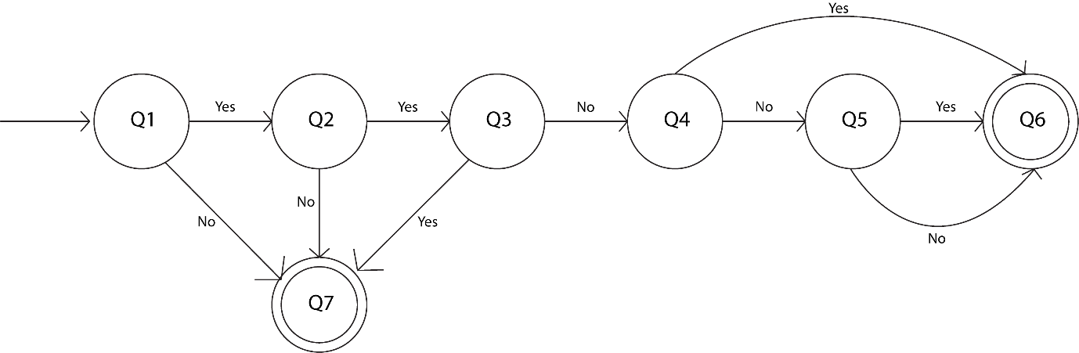

Q1: Close contact with covid patient?

Q2: Is the contact longer than 15 mins?

Q3: Was the person wearing a mask?

Q4: Were you wearing a mask?

Q5: Experienced any symptoms?

Q6: Quarantine (High Risk)

Q7: No Quarantine (Low Risk)

1. State transition table:

|  |  |  |
| --- | --- | --- |
| **STATE** | **1** | **0** |
| Q1 | Q2 (Yes) | Q7 (No) |
| Q2 | Q3 (Yes) | Q7 (No) |
| Q3 | Q4 (No) | Q7 (Yes) |
| Q4 | Q5 (No) | Q6 (Yes) |
| Q5 | Q6 (Yes) | Q6 (No) |
| Q6 | TRAP | TRAP |
| Q7 | TRAP | TRAP |